Screenshot of GitHub repository development activity for Sprint 3:

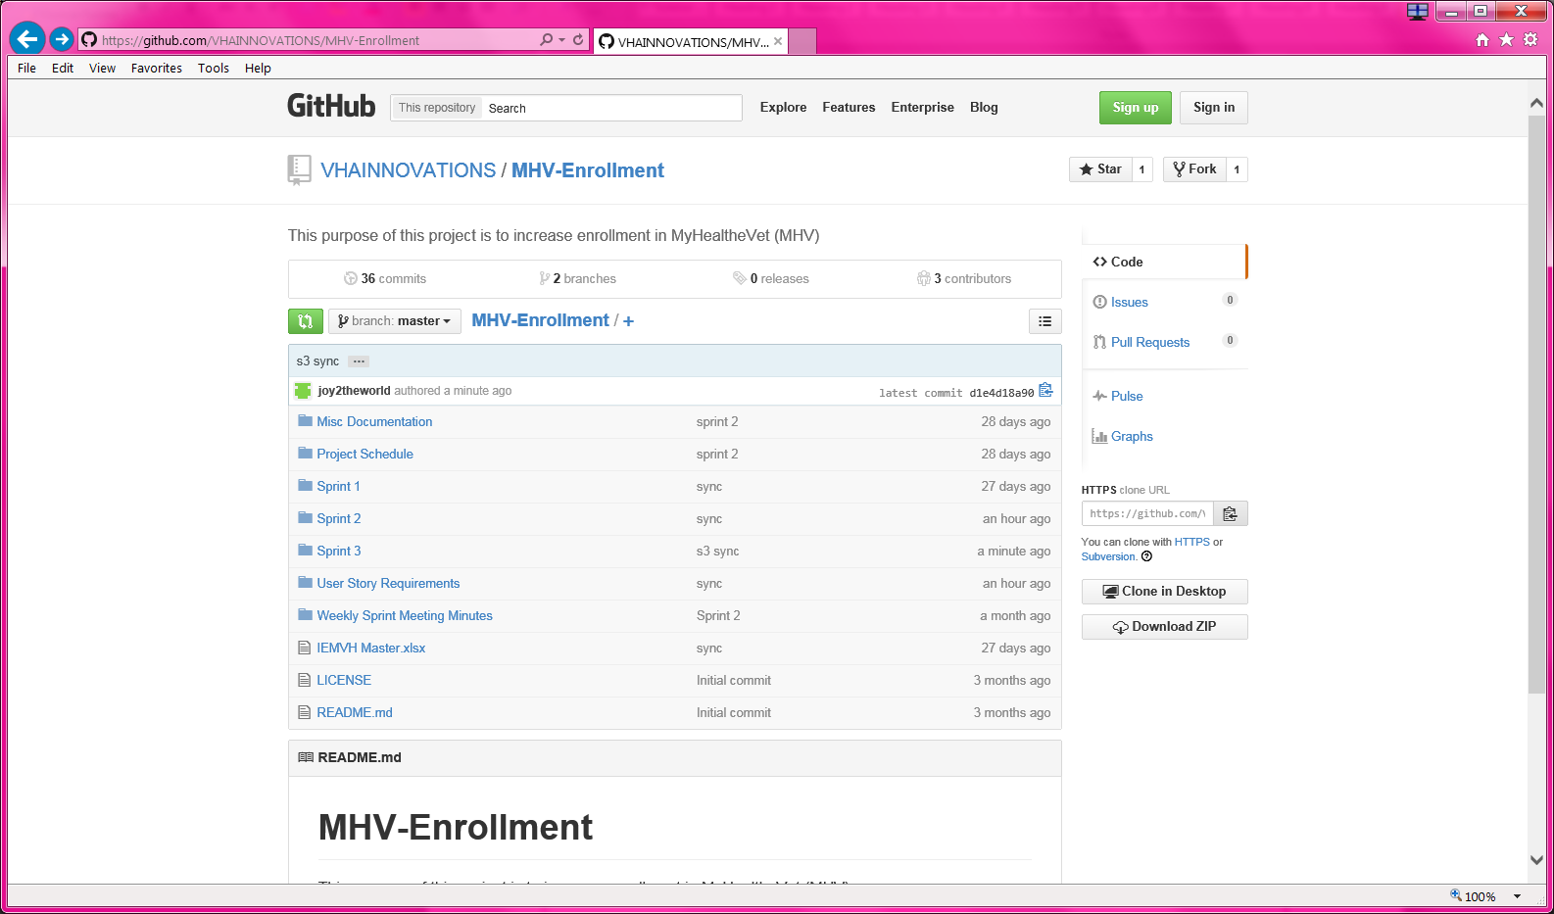

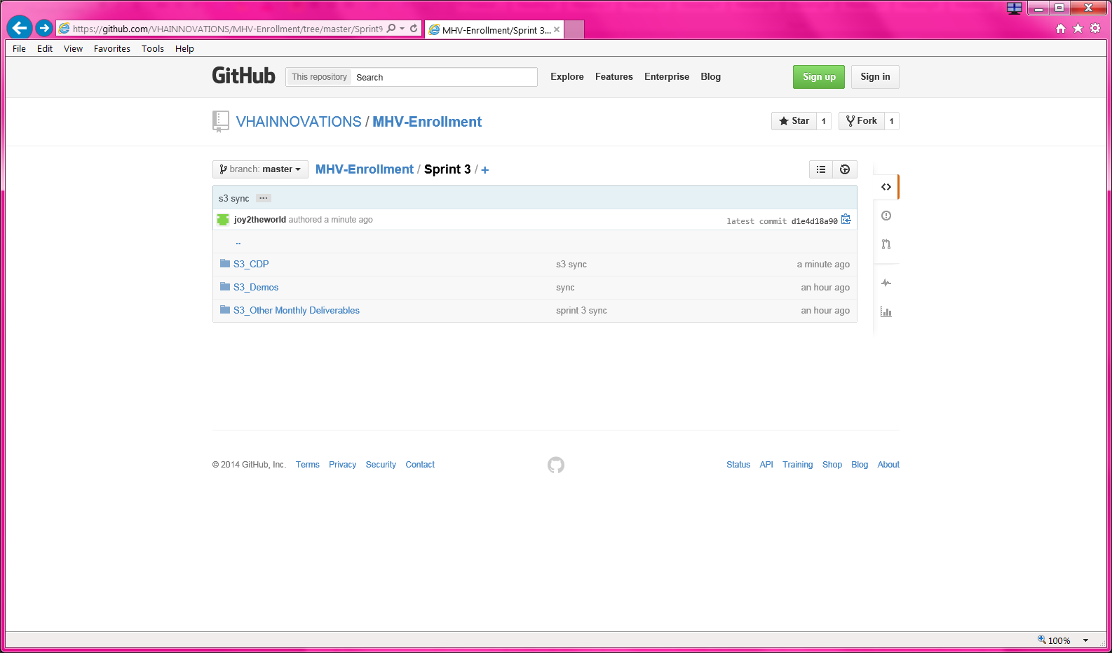

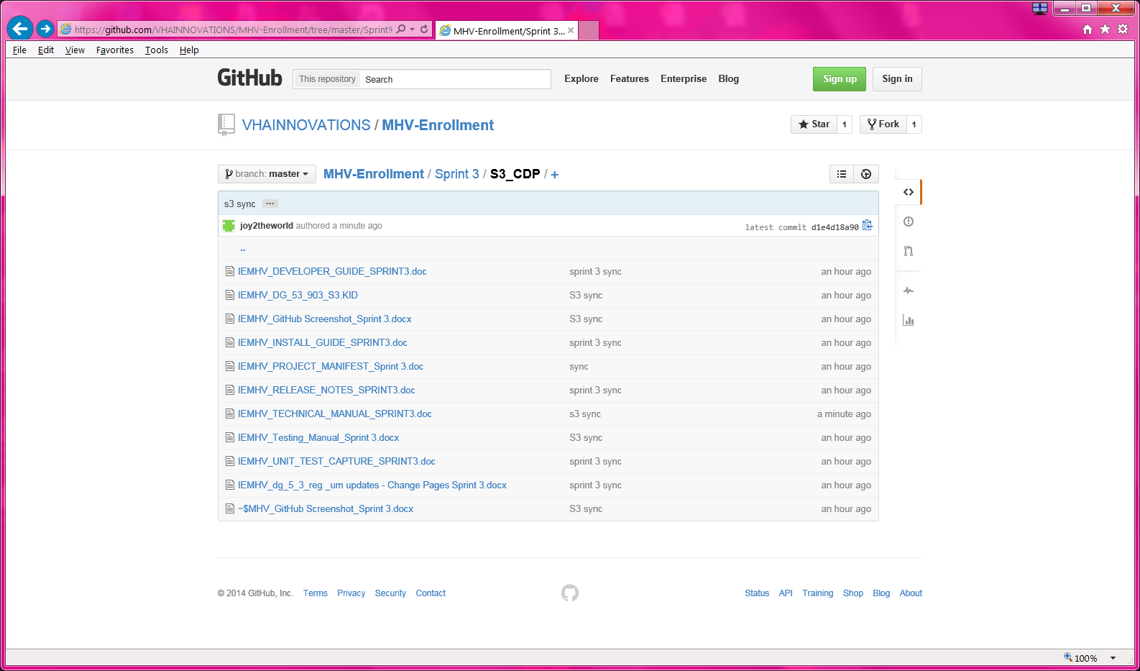

Sprint 3 CDP Inventory:

|  |  |  |  |  |
| --- | --- | --- | --- | --- |
| **Collaborative Development Package Component** | **Owner** | **Inc/Exc** | **Notes** | **Sprint 1** |
| a)     Screenshot of Git repository development activity | Joy | Include | Screenshot of GitHub w/Patch DG_53_903.kid files | IEMHV_GitHub Screenshot_Sprint 3.docx |
| b)     Source Code, Test Frameworks, Application Programming Interface (API) Frameworks, Third party | James | Include | For this enhancement, source code will be in DG_53_903.kid files | IEMHV_DG_53_903_S3.KID |
| c)     Dependencies including URLs | James | Exclude | The only Increase MHV dependency is a current VistA environment, which is basically owned and maintained by the VA. No relevant dependencies to include. | na |
| d)     Tests, test scripts and test data | James | Include | Documents developer unit test results (via attachmate emulator capture tool) | IEMHV_UNIT_TEST_CAPTURE_SPRINT3.doc |
| e)     Test configuration file | Bill | Exclude | The configuration for the ‘application’ is VistA itself. BC documented that configuration not necessary for this innovation. 10/1 | na |
| f)      Installation Guide | James | Include | Standard instructions for vista patch installation | IEMHV_INSTALL_GUIDE_SPRINT3.doc |
| g)     System Administration Guide | James | Exclude | This enhancement is not a standalone or distinct system requiring administration; there are no system administration functions/instructions to provide. | na |
| h)     Technical Manual | James | Include | Standalone doc, notate as additional content for existing VistA Registration Technical Manual => Pre-registration content | IEMHV_TECHNICAL_MANUAL_SPRINT3.doc |
| i)      Testing Manual | Bill | Include | Test scenarios w/screen shots | IEMHV_Testing_Manual_Sprint 3.docx |
| j)      Developer Guide | James | Include | Necessary to guide a developer in open source community in setting up the environment to compile, test, etc… It is very important to OSHERA certification. | IEMHV_DEVELOPER_GUIDE_SPRINT3.doc |
| k)     User Manual | Bill | Include | Standalone doc, notate as CHANGE PAGES for existing VistA Registration User Manual => Pre-registration content | IEMHV_dg_5_3_reg_um updates - Change Pages Sprint 3.doc |
| l)      Release Notes including a detailed description of changes since the previous release, bug fixes, known issues | James | Include | Content of patch description; leverage past release notes | IEMHV_RELEASE_NOTES_SPRINT3.doc |
| m)    and a manifest of remaining items to complete the project | Joy | Include |  | IEMHV_PROJECT_MANIFEST_Sprint 3.doc |